Sinhgad College of Engineering
Department of Computer Engineering

Project Approval Form
Project Gr. No. : 37 Year : 2025-26

Review Committee Members: Date: _________

Title of Project: VIDHAN : A Gamified Approach to Learning the Indian Constitution with AI Assistance.
Domain according to ACM-CCS Classification: Applied computing → Law, social and behavioral sciences → Law

No. of IEEE / Equivalent Technical papers referred: 3

Title of Review Paper-1: Constitution Connect: A Digital Platform for Promoting Constitutional Literacy Using MERN Stack.
Name of publication with Year: International Journal of Progressive Research in Engineering Management and Science (IJPREMS). [Year-2024]

Seed Idea: To create an interactive and user-friendly digital platform named "Constitution Connect" that simplifies the complex language of the Indian Constitution for the general public. It aims to promote constitutional literacy by breaking down key topics like the Preamble, Fundamental Rights, and Fundamental Duties through engaging features such as educational blogs, gamified quizzes, and a chat-bot. The entire platform is built using the modern MERN (MongoDB, Express.js, React, Node.js) stack.

Title of Review Paper-2: LawKey - Law Constitution Chatbot.
Name of publication with Year: IEEE - 2024 8th SLAAI International Conference on Artificial Intelligence (SLAAI-ICAI). [Year-2024]
Seed Idea: The core idea is to address the widespread lack of legal awareness in Sri Lanka by creating an AI-powered chatbot called "LawKey". The chatbot uses Natural Language Processing (NLP) to understand user questions (via text or voice) and provides precise legal guidance by extracting relevant laws directly from the Sri Lankan constitution. It continuously improves its accuracy over time by using reinforcement learning (Q-learning) based on user feedback.

Title of Review Paper-3: Gamification as an e-learning tool: A Literature Review.

Name of publication with Year: E-Learning Innovations Journal. [Year-2024]

Seed Idea: The results of the literature review indicate the need to systematize the existing gamification potential. Gamification of e-learning is becoming a real trend in the modern educational space. Online gaming platforms are gaining popularity among students due to their clear design and the demand for the digital cluster in the worldview paradigm of modern society.

Project Approval Review Committee Report

Review Committee Members: Date:

Names of modules for proposed system:
- Core User Modules
- User Authentication & Profile Management
- Interactive Learning Hub
- Constitutional Chat-bot Assistant
- Community & Discussion Forum
- Gamification Engine Modules
- Quiz & Challenge Module
- Rewards & Progression System
- Leaderboard & Social Ranking Module
- Administrative Modules
- Content Management System (CMS)
- User Management & Analytics Dashboard
- Quiz & Gamification Management

Platforms and Tools planned to use for implementation:
- Frontend: React.js
- Gamification: Three.js, Phaser, Zustand, React-toastify, React-confetti, Konva, Drools, Spring WebSocket
- Backend: Java Spring Boot
- Database: MySQL
- AI Chatbot Engine: NLP Library: NLTK (Natural Language Toolkit)

Identification of Input Dataset: Constitution of India
Suggestions given by Review committee members:

Approved/Approved with modification/Not Approved:

Name of Review committee member Signature

1.
2.
3.
Title: VIDHAN : A Gamified Approach to Learning the Indian Constitution with AI Assistance.
Gr. No. 37

Abstract

The Constitution of India forms the foundation of the nation’s democratic values, yet its complex legal language makes it difficult for many citizens to fully understand. This project introduces an interactive web platform designed to simplify and promote constitutional literacy among students, youth, and the general public. The platform highlights key areas such as the Preamble, Fundamental Rights, Directive Principles of State Policy, and Fundamental Duties, explained in clear and accessible language.
A distinctive feature of this solution is its ability to personalize content based on the user’s age and educational background. For younger students, the platform provides simplified explanations and playful learning activities, while for older or more advanced users, it offers deeper insights and detailed examples. To enhance engagement, the website incorporates gamified learning tools such as quizzes, puzzles, card games, spin-the-wheel activities, and board games like Snake & Ladder or Monopoly-inspired formats that connect constitutional principles to real-life scenarios. An AI-powered chatbot further supports users by answering questions, guiding navigation, and offering instant clarifications. The system also includes multimedia resources, translations in regional languages, and accessibility features to ensure inclusivity. By combining personalization, gamification, and conversational AI, the project provides a modern, enjoyable, and impactful way for citizens to learn about their rights, duties, and democratic responsibilities.

System Overview Diagram

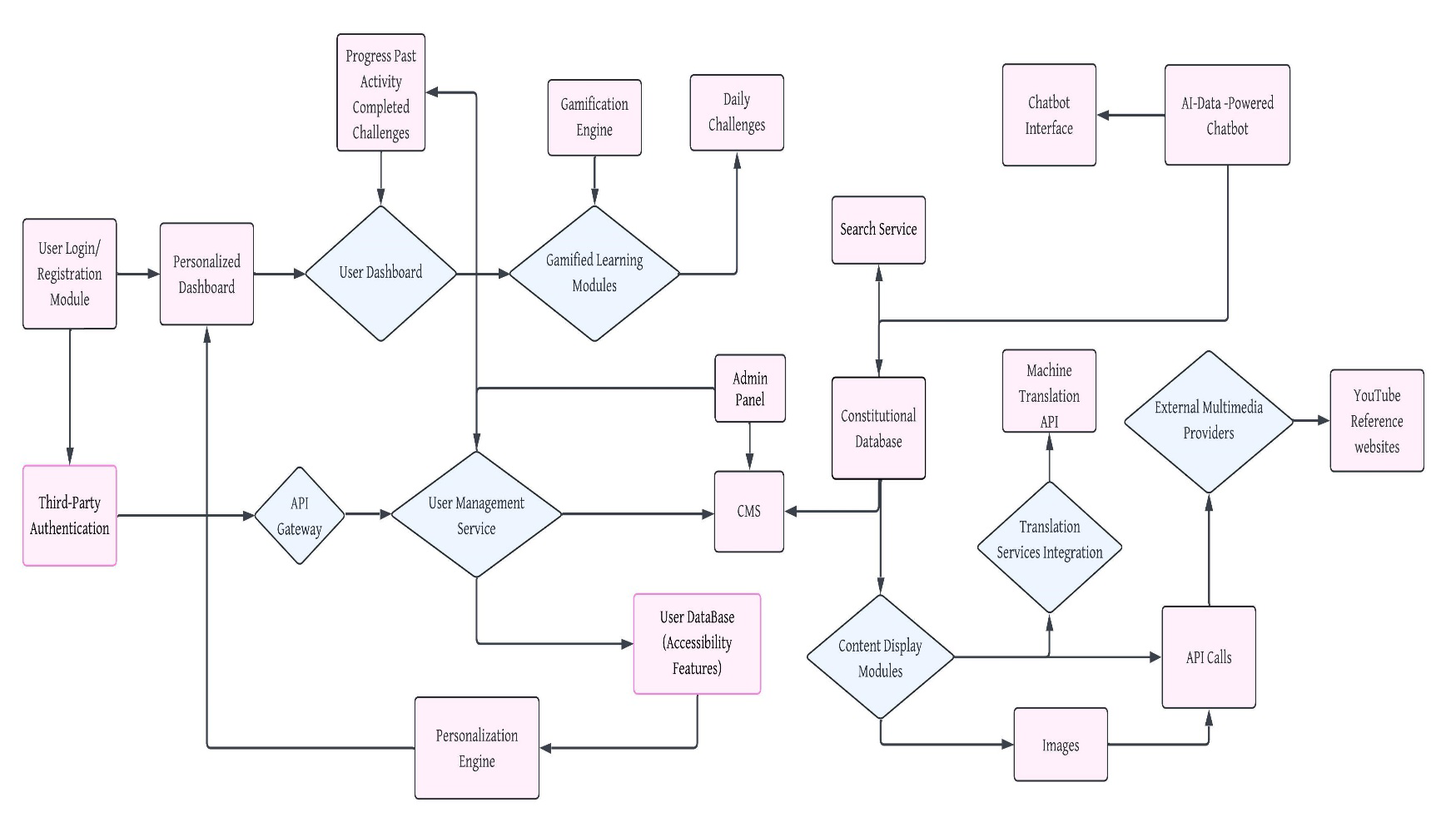
- System Overview Diagram

